**3.2 Programming the FPGA Board**.

Made the XOR circuit work where the LEDR0 would light up when switches SW0 and SW1 were different.

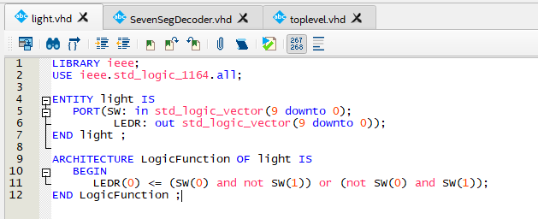

**4. Seven-Segment Decoder**

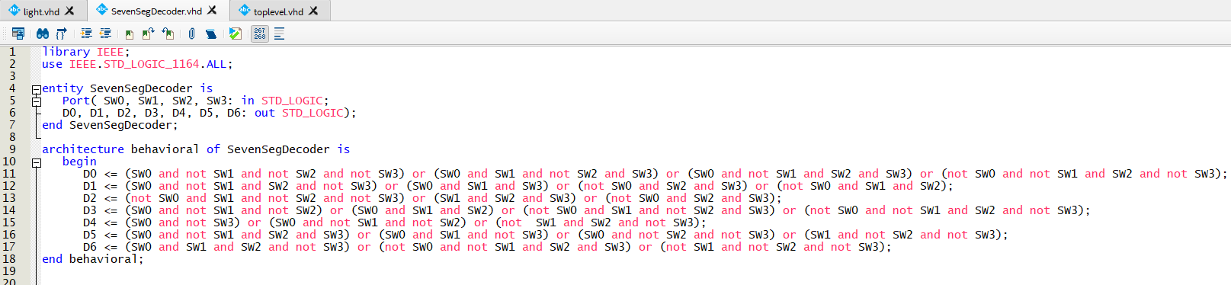

**Top-level design with 2 Seven-Segment Decoder to work with FPGA board**

Used FPGA board switches as input for the decoder and output displayed on the HEX display

